Gunther Weiss Scientific Glassblowing Co., Inc.

providing solutions for Lacrimal Bypass Surgery (CDCR) since 1963
2023 Product Catalog

LOCATION:
5295 NE Elam Young Parkway
Suite 140
Hillsboro, OR 97124 FDA: Registration #3005489143
EMAIL: info@guntherweiss.com FDA: Product Codes “HMX” and “HNL”
WEB: www.guntherweiss.com FDA: Regulation #886.4350
PHONE: 503-644-4056 ISO 9001:2015 AGS-US111219-1
FAX: 503-644-0975

cONTENTS
Title Page………………………………1
Contents………………………………...2
Part Number Guide…………………….3
2023 Pricing Guide………………….4-5
10000 Jones Tube…………………...6-7
20000 JT Gladstone-Putterman………..8
50000 JT Callahan-Cox……………….9
60000 Specialty Jones Tubes…….10-12
70000 Jones Tube Sets…………...13-14
80000 Weiss Glass Cannulas ………....15
90000 Accessories………………..16-17
How to Measure a Jones Tube………..18
Terms and Conditions…………………19

Part number guide

X X X X X - [X X] [X X]

Additional Feature
Overall Length
Flange Diameter
Family
Suture
Hole
Angle
Frosted

EXAMPLES:
- 10000 - 3512 Jones Tube Standard 3.5x12mm
- 10110 - 4020 Jones Tube Frosted with Angle 4.0x20mm
- 11000 - 4532 Jones Tube with Suture Hole 4.5x32mm

2023 pricing guide
Jones Tube Standard…………………………………………  Jones Tube no Bevel …………………………………………  Jones Tube with Angle ……………………………………..  Jones Tube Frosted …………………………………………..  Jones Tube Frosted with Angle …………………………  Jones Tube with Suture Hole …………………………….  Jones Tube with Suture Hole, Angled ……………….  Jones Tube Frosted with Suture Hole ……………….  Jones Tube Frosted with Suture Hole, Angled.……….  Jones Tube 130 Degree Angle …………………………..  Jones Tube 130 Degree Angle with Suture Hole..  Jones Tube 130 Degree Angle Frosted……………….  Jones Tube 130 Degree Angle Frosted with……….  Suture Hole  JT Gladstone-Putterman ……………………………………….  JT Gladstone-Putterman with Angle ……………………..  JT Gladstone-Putterman Frosted …………………………..  JT Gladstone-Putterman Frosted with Angle …………  JT Gladstone-Putterman with Suture Hole…………….  JT Gladstone-Putterman with Suture Hole, Angled..  JT Gladstone-Putterman Frosted with Suture Hole..  JT Gladstone-Putterman Frosted with Suture………..  Hole, Angled  JT Callahan-Cox ………..………………………………………  JT Callahan-Cox Frosted …..……………………………….  JT Callahan-Cox with Suture Hole ……………………..  JT Callahan-Cox Frosted with Suture Hole ………..  Jones Tube Double Flange ………………………………..  Jones Tube Double Flange with Suture Hole………….  Jones Tube Double Flange Frosted…………………….  Jones Tube Double Flange Frosted with Suture…  Hole  Jones Tube for CPAP………………………………………….  Jones Tube for Reduced Flow……………………………  Standard Set Jones Tubes …………………………………  Custom Set Jones Tubes……………………………………  Assorted Set Jones Tubes …………………………………  Special Set Jones Tubes ……………………………………  For additional styles of sets, see pages 11-12  Weiss Glass Cannula STRAIKO ………………………….  Weiss Glass Cannula LWVI ………………………………  Weiss Glass Cannula MIS…..………………………………  Jones Gold Dilator #1 (1.7&1.9mm Arms)…….……  Jones Gold Dilator #2 (2.2&2.4mm Arms)…….……  Jones Gold Dilator #3 (2.7&2.9mm Arms)………….  Jones Tube Sterilization Tray (Blue Anodized) …..  Jones Tube Measuring Scale……………………………… | 10000-XXXX = $52.00  10001-XXXX = $50.00  10010-XXXX = $58.00  10100-XXXX = $86.00  10110-XXXX = $90.00  11000-XXXX = $72.00  11010-XXXX = $78.00  11100-XXXX = $103.00  11110-XXXX =$110.00  10002-XXXX = $66.00  11002-XXXX = $88.00  10102-XXXX = $98.00  11102-XXXX =$106.00  20000-XXXX = $80.00  20010-XXXX = $85.00  20100-XXXX = $113.00  20110-XXXX = $117.00  21000-XXXX = $100.00  21010-XXXX = $106.00  21100-XXXX = $132.00  21110-XXXX = $137.00  50000-XXXX = $58.00  50100-XXXX = $88.00  51000-XXXX = $77.00  51100-XXXX = $110.00  60000-XXXX = $103.00  61000-XXXX = $113.00  60100-XXXX = $126.00  61100-XXXX = $130.00  60001-XXXX =$115.00  60002-XXXX =$110.00  70002-0000 = $754.00  70002-0001 = $754.00  70003-0000 = $708.00  70004-0000 = $798.00  80000-STRAIKO = $110  80000-LWVI = $175.00  80000-MIS = $180.00  90000-0001 = $67.00  90000-0002 = $67.00  90000-0003 = $73.00  90000-0005 = $499.00  90000-0007 = $61.50

10000- jONES tUBE (jt)

JT Standard
10000-XXXX
$52.00

JT Frosted
10100-XXXX
$86.00

EXAMPLES:
- 10000-3512 Jones Tube 3.5x12mm
- 10110-4020 Jones Tube Frosted with Angle 4.0x20mm
- 11000-4532 Jones Tube with Suture Hole 4.5x32mm

JT with
Suture Hole
11000-XXXX
$72.00

JT Frosted with Angle
10110-XXXX
$90.00

JT with Angle
10010-XXXX
$58.00

JT no Bevel
10001-XXXX
$50.00

Flange Sizes:
3.0mm, 3.5mm, 4.0mm
4.5mm, 5.0mm, 5.5mm
Overall Length:
9.0mm-40.0mm
*additional sizes are available upon request

10000- jONES tUBE (jt)

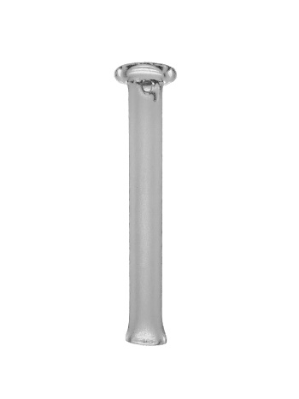
JT Frosted with Suture Hole
11100-XXXX
$103.00

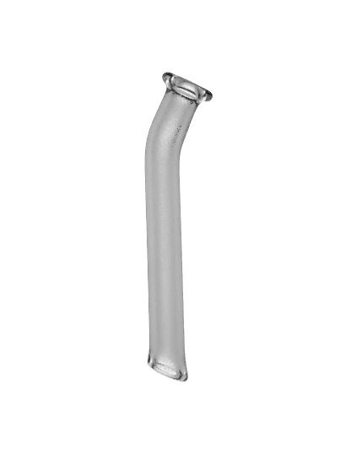
JT Frosted with Suture Hole, Angled
11110-XXXX
$110.00
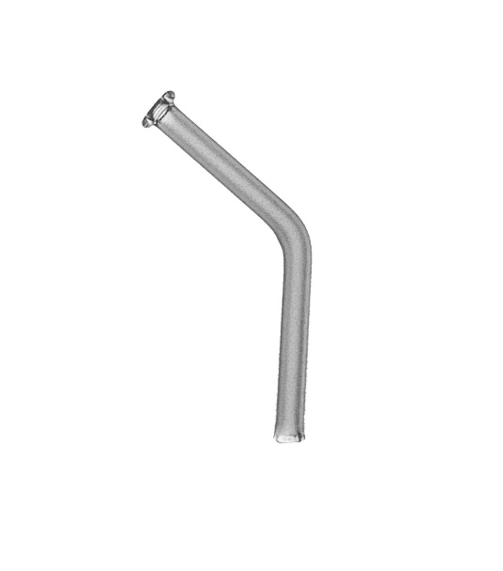

EXAMPLES:
- 10002-4024 Jones Tube 130 Degree Angle 4.0x24mm
- 11002-3528 Jones Tube 130 Degree Angle with Suture Hole 3.5x28mm
- 11100-3012 Jones Tube Frosted with Suture Hole 3.0x12mm

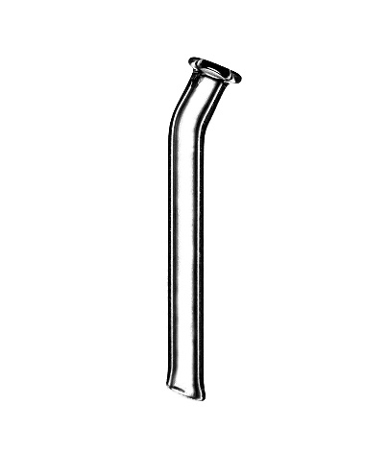
JT with Suture Hole, Angled
11010-XXXX
$78.00

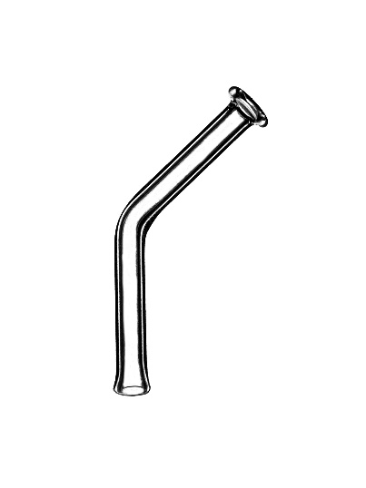
JT 130 Degree Angle
10002-XXXX
$66.00

JT 130 Degree Angle Frosted 10102-XXXX
$98.00

JT 130 Degree Angle with Suture Hole
11002-XXXX
$88.00

JT 130 Degree Angle Frosted with Suture Hole
11102-XXXX
$106.00

Flange Sizes:
3.0mm, 3.5mm, 4.0mm
4.5mm, 5.0mm, 5.5mm
Overall Length:
9.0mm-40.0mm
*additional sizes are available upon request

20000- JT Gladstone- putterman

JT Gladstone- Putterman
20000-XXXX
$80.00
JT Gladstone- Putterman Frosted with Angle
20110-XXXX
$117.00

JT Gladstone- Putterman Frosted with Suture Hole
21100-XXXX
$132.00
JT Gladstone- Putterman with Angle
20010-XXXX
$85.00
JT Gladstone- Putterman with Suture Hole
21000-XXXX
$100.00
JT Gladstone-
Putterman Frosted with Suture Hole, Angled
21110-XXXX
$137.00
JT Gladstone- Putterman Frosted
20100-XXXX
$113.00
JT Gladstone- Putterman with Suture Hole, Angled
21010-XXXX
$106.00

Flange Sizes:
3.0mm, 3.5mm, 4.0mm
4.5mm, 5.0mm, 5.5mm
Overall Length:
9.0mm-40.0mm
*additional sizes are available upon request

EXAMPLES:
- 20000-3521 JT Gladstone-Putterman 3.5x21mm
- 21000-4012 JT Gladstone-Putterman with Suture Hole 4.0x12mm
*The Gladstone Putterman Jones Tubes are available in a larger overall size
(3mm tubing instead of 2.2mm tubing) Please call for part number and pricing

50000- JT Callahan- Cox tUBEs

JT Callahan-Cox
50000-XXXX
$58.00

JT Callahan-Cox Frosted
50100-XXXX
$88.00

JT Callahan-Cox
with Suture Hole
51000-XXXX
$77.00

JT Callahan-Cox Frosted
with Suture Hole
51100-XXXX
$110.00

Flange Sizes:
4.0 mm, 4.5mm, 5.0mm, 5.5mm
Overall Length:
9.0mm-40.0mm
*additional sizes are available upon request
EXAMPLES:
- 50000-4518 JT Callahan-Cox 4.5x18mm
- 51000-4012 JT Callahan-Cox with Suture Hole 4.0x12mm
- 51100-5520 JT Callahan-Cox Frosted with Suture Hole 5.5x20mm

*The Callahan-Cox Jones Tubes are made with larger tubing
(3.0mm tubing instead of 2.2mm)

60000- Specialty Jones tubes

Jones Tube Double Flange
60000-XXXX
$103.00

Jones Tube Double Flange Frosted
60100-XXXX
$126.00

Jones Tube Double Flange
with Suture Hole
61000-XXXX
$113.00

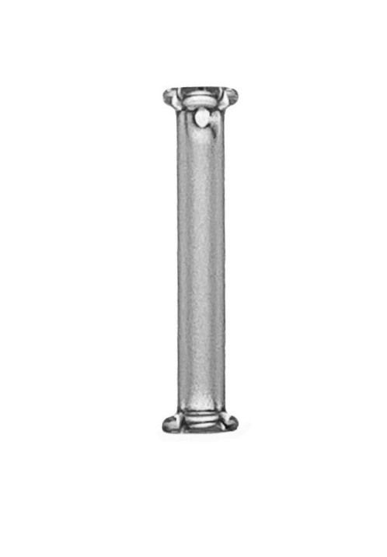

Jones Tube Double Flange Frosted with Suture Hole
61100-XXXX
$130.00

Flange Sizes:
3.0mm, 3.5mm, 4.0mm, 4.5mm
Overall Length:
9.0mm-40.0mm
*additional sizes are available upon request

EXAMPLES:
- 60000-4018 Jones Tube Double Flange 4.0x18mm
- 61000-3012 Jones Tube Double Flange Frosted 3.0x12mm

60000- Specialty Jones tubes Cont.

Jones Tube for CPAP
60001-XXXX
$115.00

Jones Tube for CPAP Frosted
60101-XXXX
$125.00

Jones Tube for CPAP with Suture Hole
61001-XXXX
$120.00

Jones Tube for CPAP Angled
60011-XXXX
$130.00

Flange Sizes:
3.0mm, 3.5mm, 4.0mm, 4.5mm
Overall Length:
9.0mm-40.0mm
*additional sizes are available upon request

EXAMPLES:
- All CPAP tubes can have combined attributes
- 60001-4017 Jones Tube for CPAP 4.0x17mm
- 61001-3511 Jones Tube for CPAP Frosted 3.5x11mm

60000- Specialty Jones tubes Cont.

Jones Tube for Reduced Flow
60002-XXXX
$110.00

Jones Tube for Reduced Flow with Suture Hole
61002-XXXX
$115.00
Jones Tube for Reduced Flow with Angle
60012-XXXX
$116.00

Jones Tube for Reduced Flow Frosted
60102-XXXX
$125.00

Flange Sizes:
3.0mm, 3.5mm, 4.0mm, 4.5mm
Overall Length:
9.0mm-40.0mm
*additional sizes are available upon request

EXAMPLES:
- All reduced flow tubes can have combined attributes
- 61002-4520 Jones Tube for Reduced Flow with Suture Hole 4.5x20mm
- 61112-3512 Jones Tube for Reduced Flow Frosted, Angled and with Suture Hole 3.5x12

70000- Jones tUBE sets

Assorted Set
70003-0000
$708.00
Set includes the following parts:
- 1ea. 3.0x10mm
- 1ea. 3.0x12mm
- 1ea. 3.0x14mm
- 1ea. 3.0x16mm
- 1ea. 3.5x11mm
- 1ea. 3.5x13mm
- 1ea. 3.5x15mm
- 1ea. 3.5x17mm
- 1ea. 4.0x15mm
- 1ea. 3.5x14mm Angled
- 1ea. 3.5x15mm Angled
Tube Style | Assorted Set | Standard Set
Jones Tube Standard | 70003-0000  $708.00 | 70002-0000  $754.00
Suture Hole | 71003-0000  $930.00 | 71002-0000  $990.00
Frosted | 70103-0000  $1,114.00 | 70102-0000  $1,192.00
Frosted with Suture Hole | 71103-0000  $1,358.00 | 71102-0000  $1,454.00
- 1ea. 4.0x14mm Angled
- 1ea. 4.0x15mm Angled
- 1ea. Gold Dilator #1
- 1ea. Gold Dilator #2
Standard Set
70002-0000
$754.00
Set includes the following parts:
- 2ea. 3.0x14mm
- 2ea. 3.5x12mm
- 2ea. 3.5x13mm
- 2ea. 3.5x14mm
- 2ea. 3.5x15mm
- 2ea. 4.0x15mm
- 1ea. 4.0x16mm
- 1ea. 4.0x18mm
- 1ea. Gold Dilator #1
- 1ea. Gold Dilator #2

70000- jones tube sets

Special Set
70004-0000
$798.00
Set includes the following parts:
- 1ea. 3.0x10mm
- 1ea. 3.0x11mm
- 1ea. 3.0x12mm
- 1ea. 3.0x13mm
- 1ea. 3.0x14mm
- 1ea. 3.0x15mm
- 1ea. 3.5x09mm
- 1ea. 3.5x11mm
- 1ea. 3.5x17mm
- 1ea. 3.5x18mm
- 1ea. 4.0x12mm
- 1ea. 4.0x13mm
- 1ea. 4.0x14mm
- 1ea. 4.0x17mm
- 1ea. 4.0x19mm
- 1ea. Gold Dilators #1 and #2
Tube Style | Special Set | Custom Set
Jones Tube Standard | 70004-0000  $798.00 | 70002-0001  $754.00
Suture Hole | 71004-0000  $1,050.00 | 71002-0001  $990.00
Frosted | 70104-0000  $1,268.00 | 70102-0001  $1,192.00
Frosted with Suture Hole | 71104-0000  $1,550.00 | 71102-0001  $1,454.00
Custom Set
70002-0001
$754.00
Set includes the following parts:
- 14 tube sizes of your choice
- 1ea. Gold Dilator #1
- 1ea. Gold Dilator #2

80000- Weiss Glass Cannulas
Weiss Glass
Cannula- STRAIKO
80000-STRAIKO
$110.00

Weiss Glass
Cannula- LWVI
80000-LWVI
$175.00

Weiss Glass
Cannula- Miracles in Sight
80000-MIS
$180.00

90000 Accessories

Jones Gold Dilator #1
(1.7&1.9mm arms)
90000-0001
$67.00

Jones Tube Measuring Scale
90000-0007
$61.50

Jones Gold Dilator #2
(2.2&2.4mm arms)
90000-0002
$67.00

Jones Gold Dilator #3
(2.7&2.9mm arms)
90000-0003
$73.00

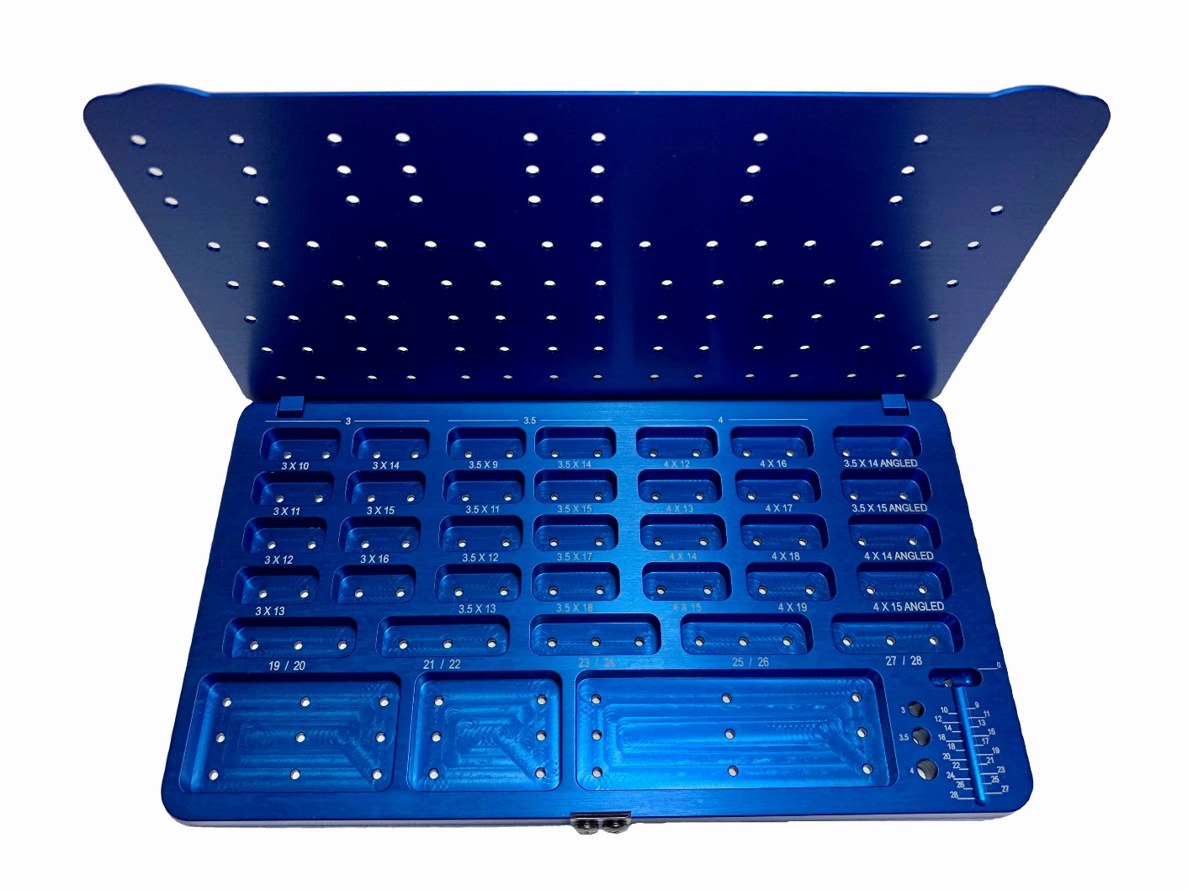

90000 Accessories

Jones Tube Sterilization Tray (Blue Anodized)
90000-0005
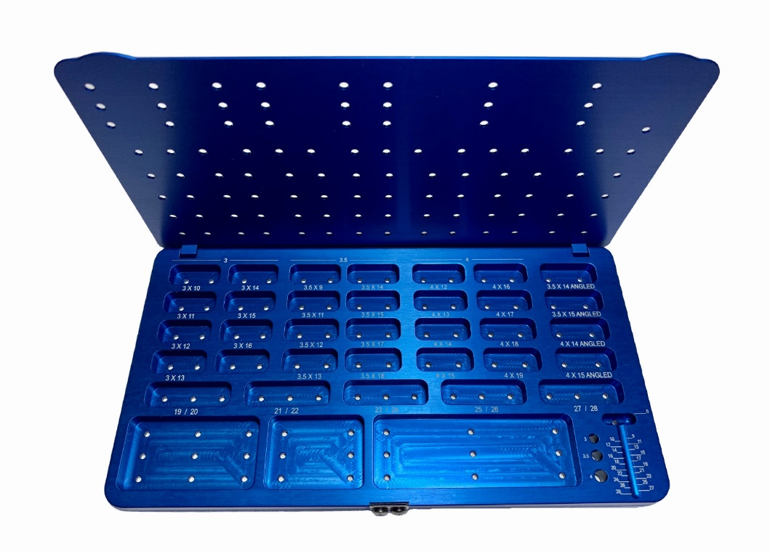
$499.00

Measuring Scale (reference only)

how to measure
a jones tube
There are two ways to measure the overall length of a Jones Tube:

Measuring an
Angled Jones Tube

- All Jones Tubes are measured with a caliper prior to shipping.
- When measuring a Jones Tube with angle the flange end is aligned flatly against one jaw of the caliper and the caliper is closed until it just touches the beveled end of the tube.
- The Jones Tube below is a 19mm Jones Tube with angle.

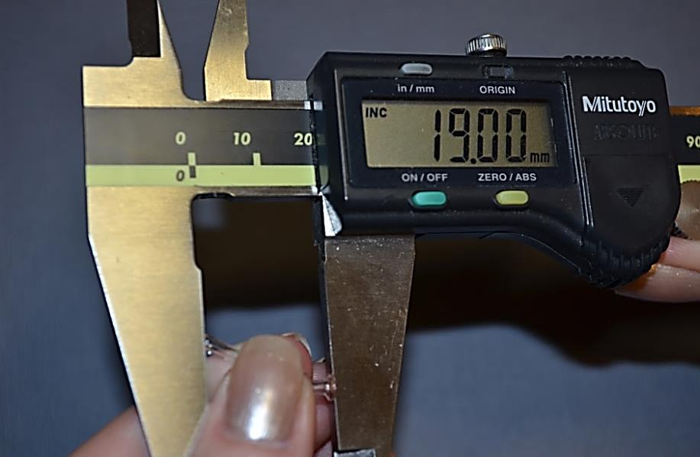

These three circular holes are used for reference to measure the top of the Jones Tube (flange). Calipers can also be used for sizes beyond this scale.

Using the Blue Anodized
Sterilization Tray or Measuring Scale
(90000-0005, 90000-0007)

- Always make sure that the flange end is touching the end of the measure scale marked with the zero.
- The beveled end of the tube should be rotated so that the very extreme beveled tip of the tube is aligned with the side of the scale that aligns best with the tip.
- The tolerance for the Jones Tube is +/- 0.3 MM.
- The Jones Tube in the photo below is 24mm

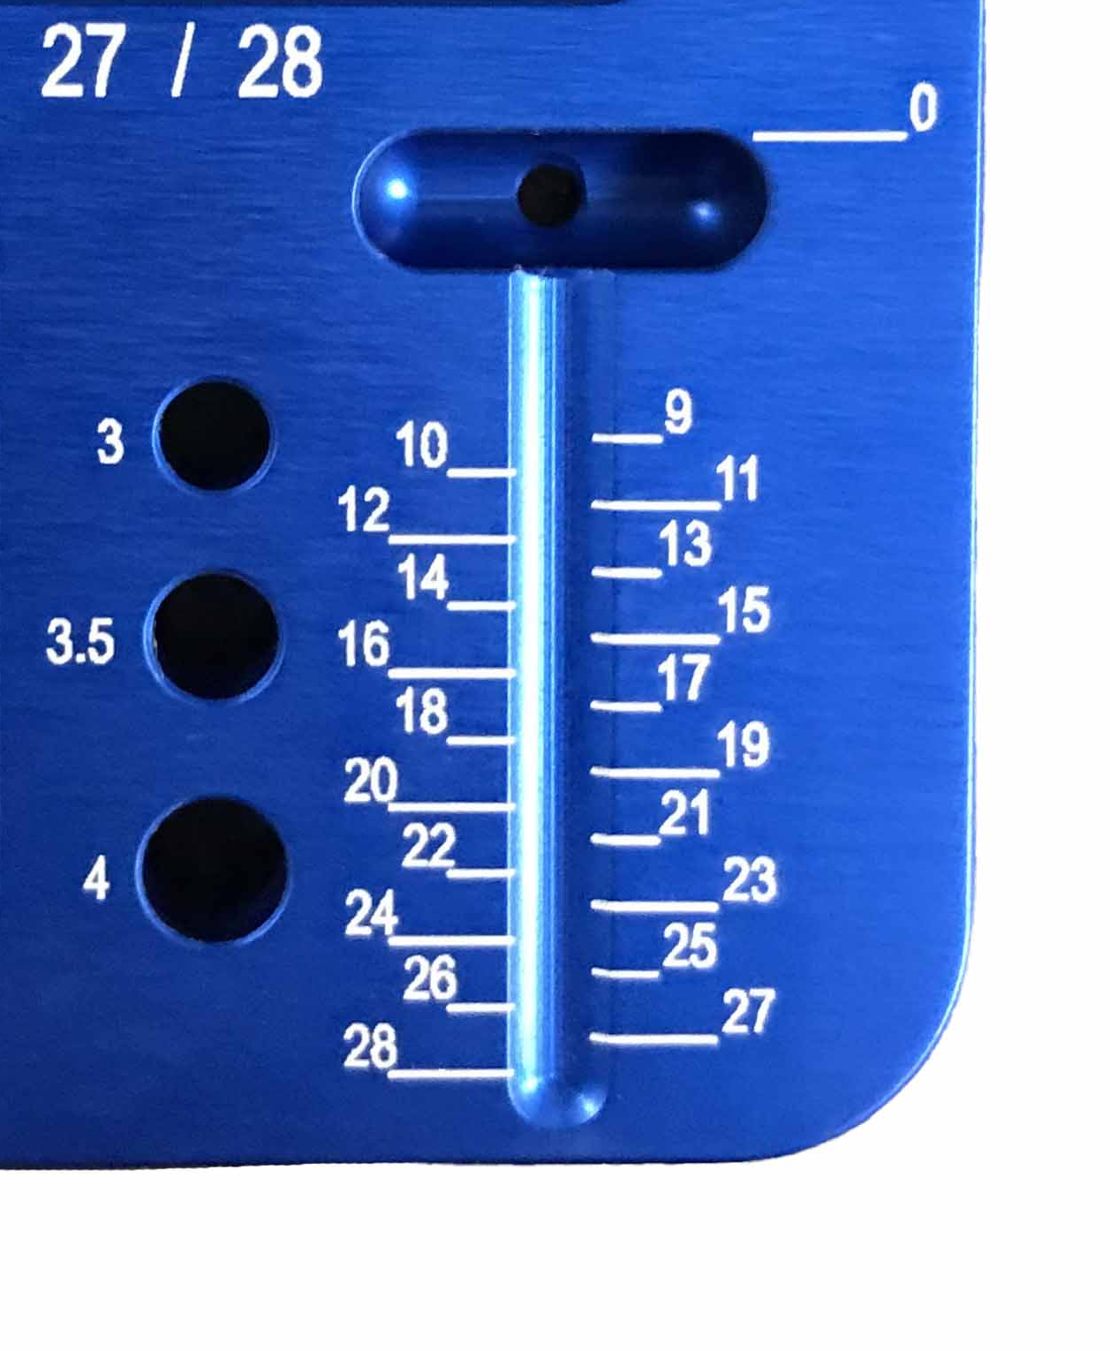

Terms and Conditions

- Shipping: FOB origin, typically UPS ground, unless otherwise specified within two weeks of order. No shipments via US mail due to losses and an inability to track shipments.
- Payment terms: Net 30, 1.5% per month over 30 days is prefered. We do accept VISA or MasterCard for a 3% processing fee.
- Overseas Payment terms: All overseas orders will need to be paid in advance with a credit card. No shipments will be sent until payment is received.
- Return policy: Because we wish to ensure that our customers receive only newly manufactured Jones Tubes, we will not accept returns on these products. If you find you have ordered incorrect product please refuse our delivery prior to receiving your order from our shipper and before opening the box. Otherwise, we are unable to accommodate returns. Items other than Jones Tubes may be returned for credit if in new condition.
- Preferred carrier: UPS
- Additional Charge: Customers requesting special shipping instructions outside of Gunther Weiss Scientific’s “preferred carrier” shall be assessed an additional handling charge for their request.

